Divide-and-Conquer Algorithm
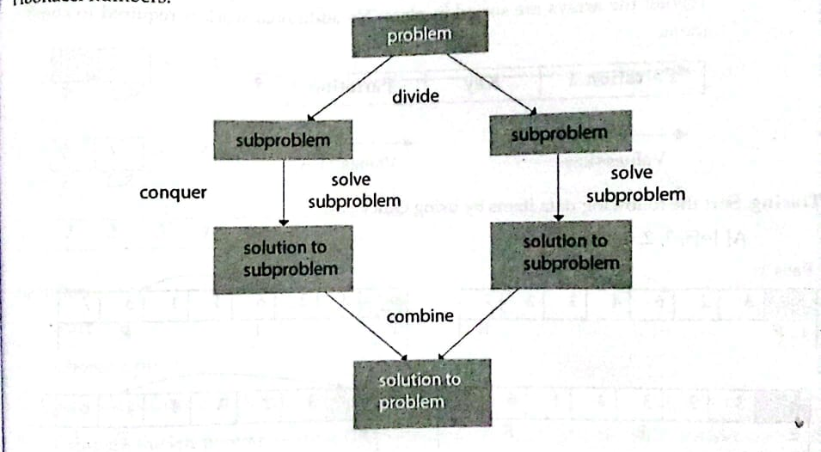
An important problem-solving technique that uses the concept of recursion is the divide-and-conquer approach. It is an algorithmic design paradigm in which a problem is solved by recursively breaking it into smaller, similar sub-problems, solving each independently, and then combining their solutions to obtain the final result for the original problem.
Using this approach, the main problem is divided into smaller sub-problems, each representing a portion of the original problem. This division continues until the sub-problems become so small that they cannot be divided further (atomic level). These smallest sub-problems are then solved directly. Finally, their solutions are combined to produce the solution to the original problem.
Broadly, the divide-and-conquer approach consists of three main steps:
- Divide (Break):
The problem is recursively divided into smaller sub-problems until no further division is possible. Each sub-problem represents a part of the original problem.
- Conquer (Solve):
At this stage, each smallest sub-problem is solved individually and directly, as it is simple and cannot be divided any further.
- Combine (Merge):
The solutions of the sub-problems are recursively combined to form the solution to the original problem. In practice, the conquer and combine steps are closely related and often appear as a single phase.
Comparative Study of Time and Space Complexity of Sorting Algorithms
Sorting Algorithm | Time Complexity |  |  | Space Complexity
 | Best Case | Average Case | Worst Case
Bubble Sort | O(n) | O(n2) | O(n2) | O(1)
Selection Sort | O(n2) | O(n2) | O(n2) | O(1)
Insertion Sort | O(n) | O(n2) | O(n2) | O(1)
Merge Sort | O(n log(n)) | O(n log(n)) | O(n log(n)) | O(n)
Quick Sort | O(n log(n)) | O(n log(n)) | O(n2) | O(n)
Heap Sort | O(n log(n)) | O(n log(n)) | O(n log(n)) | O(1)
Shell Sort | O(n log(n)) | O(n log(n)) | O(n2) | O(1)

